LHC- - - 1999-09-22
Installation Procedure
ALICE central chamber installation procedure for LS2
Abstract
This document describes the installation procedure for LS2 of the ALICE central chamber to be housed in point 2 of the LHC.
Prepared by :  J CHAURE  Data contributed by:  G.Schneider  C.Gargiulo |  |  | To be Checked by :  Josef Sestak  Corrado Gargiulo |  | To be Approved by :  Arturo Tauro  Giuseppe Bregliozzi
History of Changes
Rev. No. | Date | Pages |  | Description of Changes
0 |  | - |  | New document

Contents
Contents 3
1. introduction 4
2. PRACTICAL and SAFETY INFORMATIONS 4
3. ALICE beam pipe layout after LS2. Error! Bookmark not defined.
4. Summary of the installation phase. 6
5. ALICE beam pipe VC2C Drawing. Error! Bookmark not defined.
6. TOOLING and material 8
7. Detailed Description of Assembly 9
8. Assembly of the manual gate valve (VVGMT) support 21

Abbreviations
Abbreviations | Full Name of Component
ALICE | A Large Ion Collider Experiment
TE/VSC | Technology department/ Vacuum Surfaces and Coatings Group
RSO | Radiation Safety Officer
LHC | Large Hadron Collider
IP | Interaction Point
CS | Central Section
BP | Beam Pipe
LSS | Long Straight Section
NEG | Non-Evaporable Getter
RB 24 | Beam Pipe after CS towards IP1
RB 26 | Beam Pipe after CS towards IP3
TPC | Time Projection Chamber
WM | Warm Module
TRS | Temporary Rails Supports
OMG_PLTF | Omega Platform
CG_TBL | Cage Table

introduction
The ALICE experiment with the central beryllium beam pipe, as seen in Figure 1 is located at Point 2 of the LHC ring.
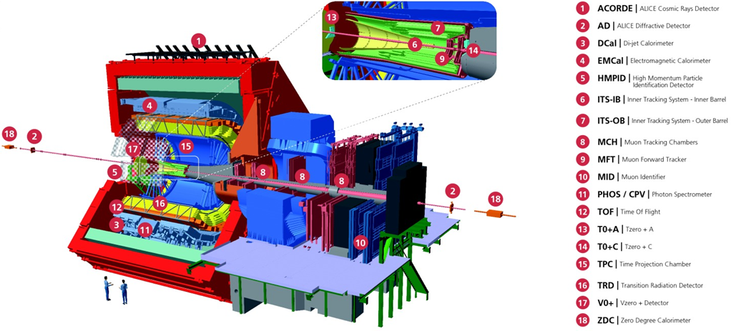
Figure 1: ALICE experiment
The installation of the vacuum chamber and the equipement associated, implies a common approach between the VSC group and ALICE. This procedure details all the installation phases by designating the group in charge according to the tasks to be performed.
For all the phases that ALICE are in charge, follow the instructions in the ALICE procedure (hence after called as ALI_INT).

PRACTICAL and SAFETY INFORMATIONS
- ALICE RSO must be informed beforehand and decide based on the ALARA level if the intervention requires WDP and DIMR. ALICE RSO will decide if the DMC dosimeter must be switch ON with the impact number associated to the activity.
- To access to the experimental cavern, an Impact should be create and it will validate by the technical coordinator from ALICE.
- All online training and safety courses must be valid during all the period of the mechanical intervention:
  - CERN - LHC Large Experiments / CERN - Grandes Expériences du LHC
  - Safety at CERN / La Sécurité au CERN
  - Radiation Protection - Awareness / Radioprotection - Sensibilisation
  - Emergency Evacuation / Évacuation en cas d'urgence
  - ALICE - Surface and Underground Areas / ALICE - Zones de Surface et Souterraine
  - Electrical Safety - Awareness - Fundamentals / Sécurité Électrique - Sensibilisation – Fondamentaux
  - Electrical Safety - Awareness - Facilities / Sécurité Électrique - Sensibilisation - Installations
  - Work at heights and Mobile Elevating Working Platform are not mandatory.
- In the case of materials shipping or transport, ALICE cavern is located in building 2285 (SX2).

ALICE EXPERIMENTAL BEAM VACUUM LAYOUT
Mechanical changes within the ALICE experimental beam vacuum layout are described within the ECR LHC-VC2-EC-0001.

ALICE experimental vacuum layout before the LS2
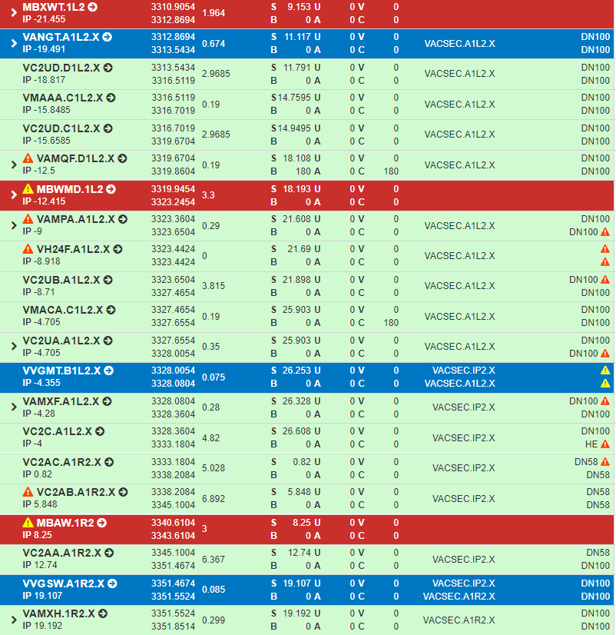

ALICE experimental vacuum layout AFTER the LS2
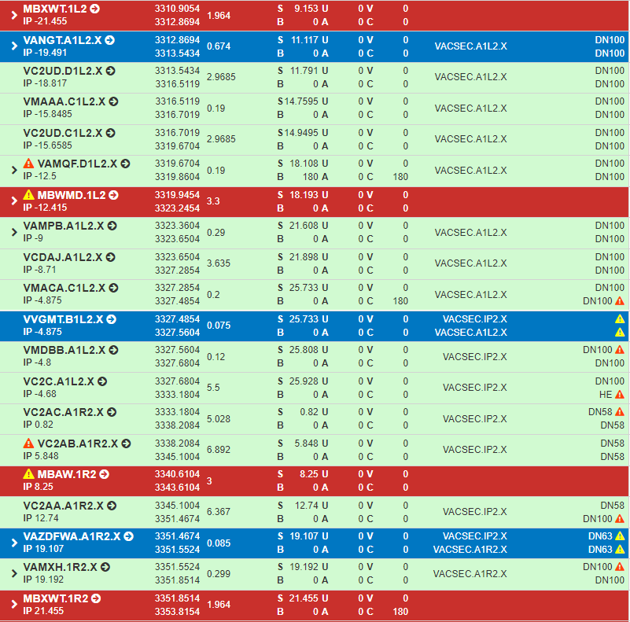

Summary of the installation phase.
- The beam pipe supports Middle and C side are in place inside the Cage > ALICE (ALI_INT).
- The temporary beam pipe valve support is in place on the Temporary Rail Support, and his position is adjusted > ALICE (ALI_INT).
- The dry insertion test of the Cage, together with the Temporary Support System, was performed through the TPC to the final position > ALICE (ALI_INT).
- Install the centrale beryllium beam pipe VC2C in the cage on the supports.
- Install the manual gate valve VVGMT on the temporary support.
- Install the warm module.
- Preconnection of the bakeout equipment side A.
- Move the Cage to its final position through TPC > ALICE (ALICE Internal procedure).
- Connect the Centrale Beryllium Beam Pipe VC2C to RB26/1.
- Pump down and leak detection from VVGMT to RB26/1.
- Bakeout installation.
- Bakeout and NEG activation > (EDMS 926404).
- Move the TPC to its final position > ALICE (ALI_INT).
- Install the support of the manual gate valve support > ALICE (ALI_INT).
- Install and transfer the charge on the manual gate valve support.
- Final survey of the Cage and Beam Pipe > ALICE (ALI_INT).

EQUIPMENT AND LAYOUT DRAWIGNS
Vacuum layout of the ALICE experimental beam vacuum system is described by:

- LHCVC2__0004 Vacuum equipment in B1L2.X (Q1-RB24)
- LHCVC2__0005 Vacuum equipment in A1L2.X (RB24)
- LHCVC2__0006 Vacuum equipment in IP2.X (RB26)
- LHCVC2__0007 Vacuum equipment in A1R2.X (RB26-Q1)
- LHCVC2__0008 Vacuum equipment in IP2.X (Q1-Q1)

Particularly important details in terms of the mechanical update on the upstream side of the IP2 are shown by drawing LHCVC2__0005.
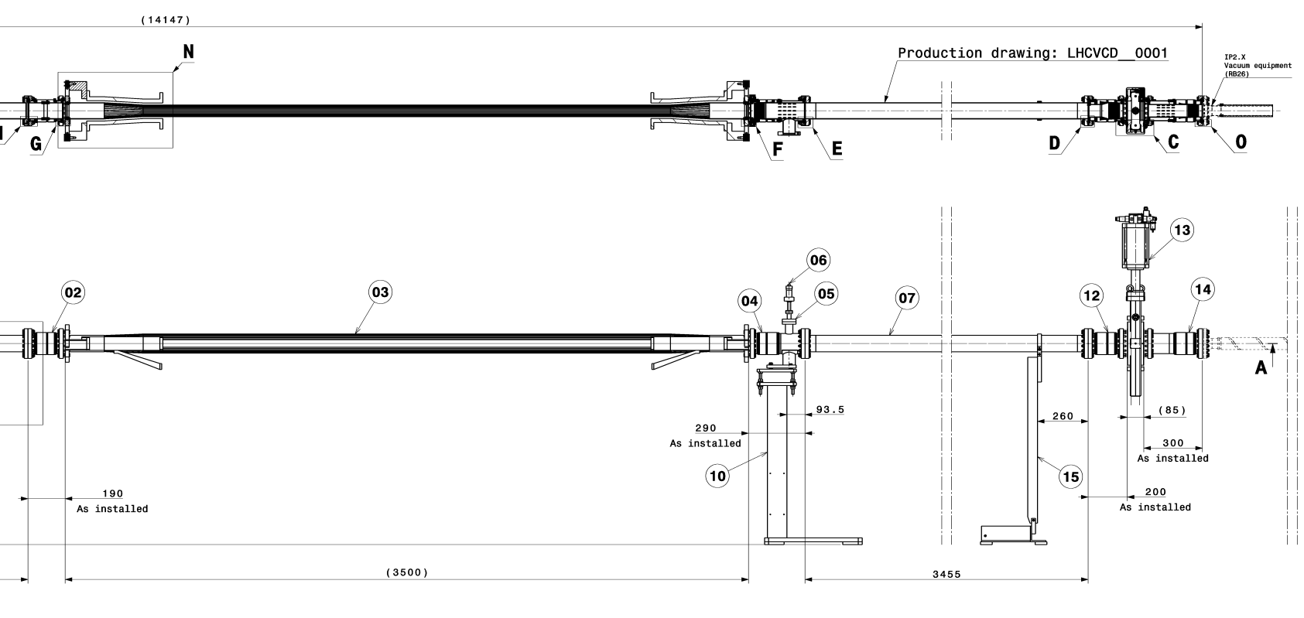
Manual Gate Valve :
VVGMT.49.1L2.X
RB24 : A1L2.X
                - Figure 2 ALICE beam vacuum system in RB24
Central Beam Pipe VC2C

Vacuum equipment to be installed is:

- VPIAN Sputter ion pump VacIon plus 75 (to be installed with A1L2.X);
- LHCVCD__0001 Standard drift vacuum chamber L3635mm (to be installed with A1L2.X);
- LHCVMACA0002 LHCStandard warm vacuum module, type VMACA (to be installed with A1L2.X);
- VVGMT Manual sector gate valve with RF bridge (ID63);
- LHCVMDBB0001 LHCStandard warm vacuum module, type VMDBB;
- LHCVC2C_0024 Central aluminium-beryllium chamber;
- VVGSWA Electro-pneumatic sector valve with additional port DN63;
- Penning; pirani and Bayard-Alpert gauges according to the layout.

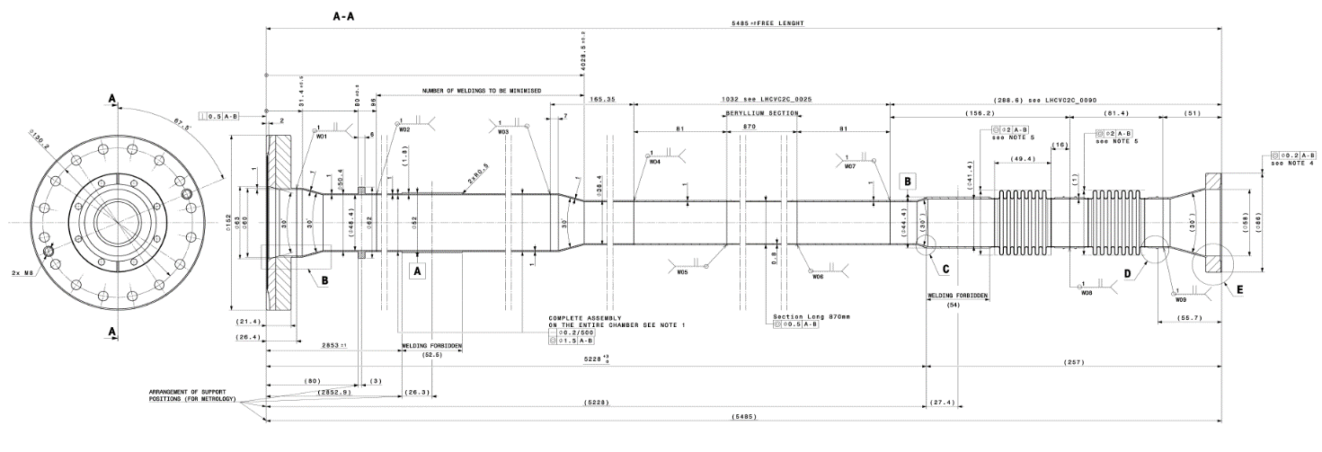
                - Figure 3 ALICE Central chamber for Run3

TOOLING and material
- Spanner set from 8 to 19.
- Set Hexagon key L 1.5 to 10.
- Screwdriver set slot and pozidriv head.
- Torque wrench 1Nm – 10Nm with Screwdriver bits hexagon 4mm.
- Socket set 1/4".
- Socket set 1/2".
- Tape measure, spirit level, steel rule, vernier caliper.
- Pliers set, cutter.
- Aluminium, kapton foil, Aluminium tape, Kapton tape.
- Alcool Ethylique, vacuum cleaning foam.
- Gloves for UHV.
- Camera.
- Cable ties L 400mm (Ty-Rap®).

Detailed Description of Assembly
Step Nbr | Resp. | Description | Time
 | TE/VSC | Transport request for Central Beryllium Beam Pipe VC2C to SX2
 | ALICE | Installation of the platform for the installation of the Beryllium beam pipe VC2C.  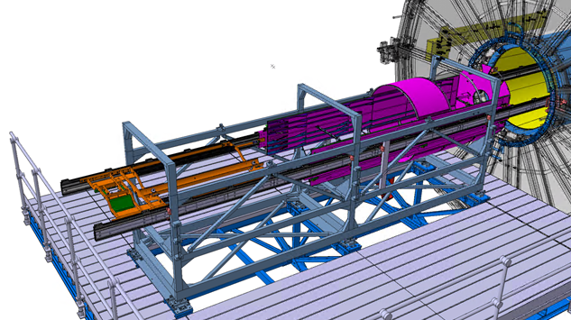
1 | ALICE | Remove the top brackets of the BP support.  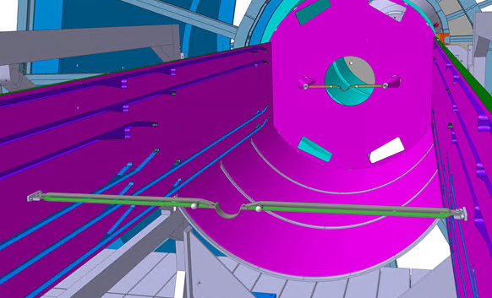

2 | EN/HE | Lower the crate of the beryllium beam pipe VC2C through the ALICE Delphi Frame.  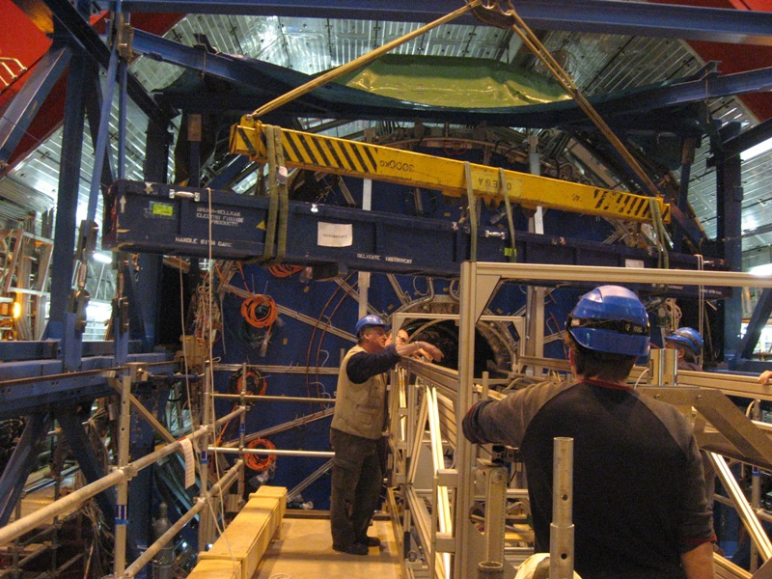
3 | TE/VSC | Unpack Central Beryllium Beam Pipe VC2C.  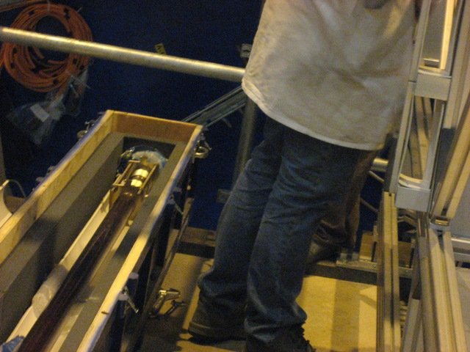 | 5min

4 | TE/VSC | Turn the beampipe VC2C to have the top position on the top. Cf EDMS doc: 2133870  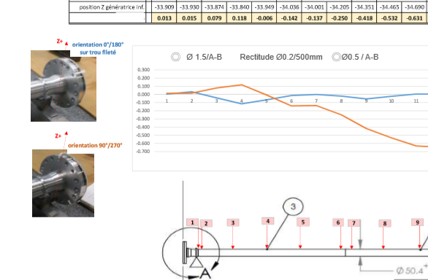 | 5min
5 | TE/VSC | Remove the bottom protection sleeve from the aluminium bellows. Keep the top protection sleeve attached with cable ties. | 10min
6 | TE/VSC | Lift central Beryllium Beam Pipe VC2C with 2 peoples and insert the BP inside the cage from the A-side. A third people receive the BP on the C-side.  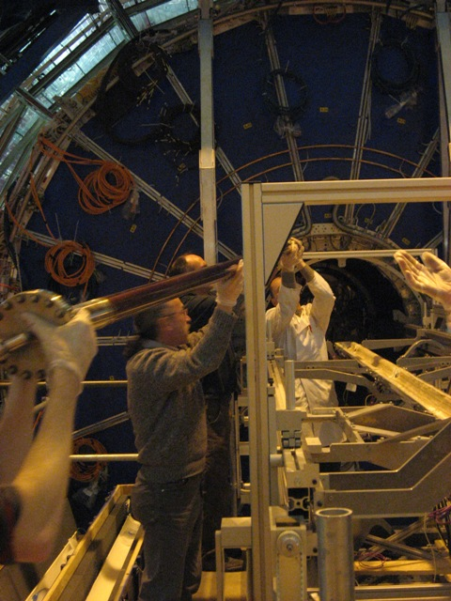 | 10min

7 | TE/VSC | Transfer the Beam Pipe VC2C on the Beam Pipe Supports.  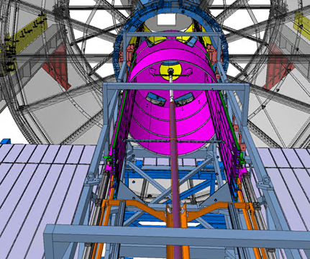 | 5min
8 | ALICE | Install BP Valve block and connect its bellow to the BP central section by adjusting the BP Valve block position along z such the BP is in the correct position. Verify BP versus BP Middle Support.  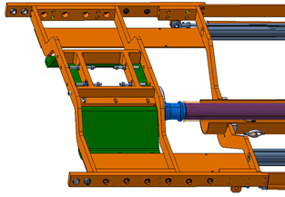

9 | TE/VSC | Install the manual valve VVGMT on its temporary support  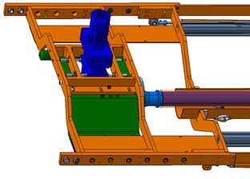 | 15min
10 | ALICE | Install support bracket across the BP Valve Temporary support.  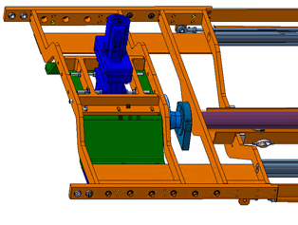
11 | TE/VSC | Install lower support on the manual valve VVGMT to avoid a pendulum when the valve is under vacuum.  Remove the flanges CF100 on the manual valve VVGMT and on the Central Beam Pipe VC2C.  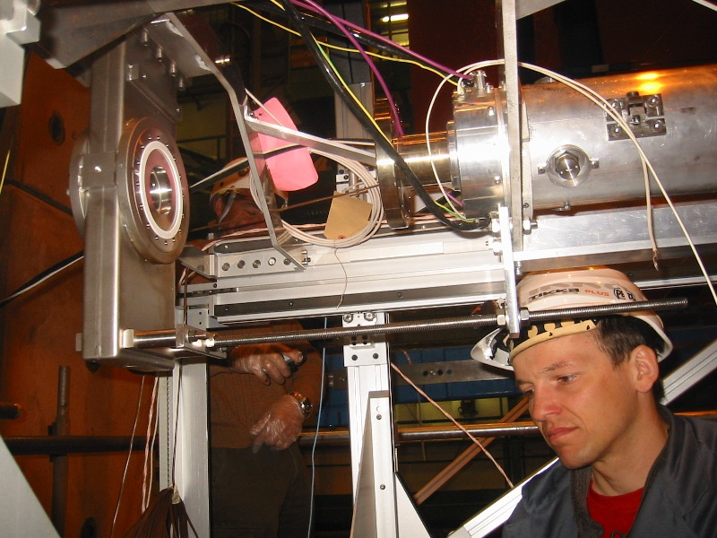 | 15min
12 | TE/VSC | Assure that the manual gate valve VVGMT is locked in the CLOSE position.  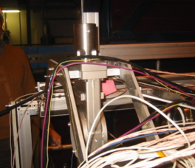 | 2min
13 | TE/VSC | Mount the warm module between the valve VVGMT and the chamber VC2C. | 30min
14 | TE/VSC | Open the Manual gate valve VVGMT. | 5min
15 | TE/VSC | Remove the top protection sleeve from the aluminium bellows of the chamber VC2C and install the tooling to block the bellows in place. (photo à venir) | 15min
16 | TE/VSC | Install the flange OD86 with pumping port on the centrale chamber VC2C, with new Helicoflex seal ref. 204606 and tight the flange. | 15min
17 | EN/HE | Transport a pumping group and a leak detector on the Delphi Frame, TPC side, near the pumping port of the chamber VC2C.
18 | TE/VSC | Install a T KF16 on the pumping port of the centrale chamber VC2C, connect on it the pumping group and the N2 bottle. Connect the leak detector on the pumping group. | 10min
19 | TE/VSC | Install bags around the flanges of the warm module. | 10min
20 | TE/VSC | Pump down experimental beam chambers to less than 1E-06 mbar on the pressure gauge of the pumping group.  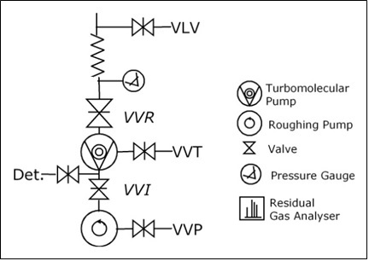 | 4hr
21 | TE/VSC | Start the leak detector. Connect the leak detector on the computer to save the data of the measurement.  - Measure the background of the detector during 10min, should below 1E⁻¹⁰mbar.l/sec.  - Close VVR and open the Det. Valve, measure the leak rate during 10min.  - Open VVR measure the leak rate during 10min | 40min
22 | TE/VSC | Tightness of manual gate valve (VVGMT.43.1L2.X)  - Close VVGMT.43.1L2.X  - Remove the blank flange CF100.  - Check the pressure on the pressure gauge of the pumping group.  - if the pressure increase, close VVR, vent the BP with N2, change the VVGMT valve, and repeat step 20, 21 and 22.  - If the pressure is stable, inject He around the VAT seal:  - If the leakrate increases after 10min, close VVR, vent the BP with N2, change the VVGMT valve, and repeat step 20, 21 and 22.  - If the leakrate is stable, reinstall blank flange CF100 with a new seal and pass to the next step  DON’T OPEN THE MANUAL GATE VALVE (VVGMT) UNTIL THE SECTOR IS NOT FILL AT ATMOSPHERIC PRESSURE WITH N2. | 30min (WO leak)
23 | TE/VSC | Seal tightness test of the warm module flanges  - Inject He on the flange between the valve and the warm module.  - If the leakrate increases after 10min, close VVR, vent the BP with N2, change the seal, and repeat step 20, 21 and 23.  - If the leakrate is stable, test the second flange.  - Inject He on the flange between the warm module and the BP.  - If the leakrate increases after 10min, close VVR, vent the BP with N2, change the seal, and repeat step 20, 21 and 23.  - If the leakrate is stable, remove the bags and pass to the next step | 30min (WO leak)
24 | TE/VSC | - Close the VVR valve on the pumping group and measure the leak rate during 10min.  - Close the leak detection valve and measure the leak rate during 10min. | 25min
25 | TE/VSC | Vent the BP at atmospheric pressure with N2. | 10min
26 | TE/VSC | Open the manual valve VVGMT. | 5min
27 | TE/VSC | Pump down experimental beam chambers to less than 1E-06 mbar on the pressure gauge of the pumping group. | 4hr
28 | TE/VSC | Start the leak detector. Connect the leak detector on the computer to save the data of the measurement.  - Measure the background of the detector during 10min, should below 1E⁻¹⁰mbar.l/sec.  - Close VVR and open the Det. Valve, measure the leak rate during 10min.  - Open VVR measure the leak rate during 10min | 40min
29 | TE/VSC | Seal tightness test of the blank flange of the VVGMT valve.  - Inject He on the blank flange.  - If the leakrate increases after 10min, close VVR, vent the BP with N2, change the seal, and repeat step 27, 28 and 29.  - If the leakrate is stable, pass to the next step. | 15min (WO leak)
30 | TE/VSC | - Close the VVR valve on the pumping group and measure the leak rate during 10min.  - Close the leak detection valve and measure the leak rate during 10min. | 25min
31 | TE/VSC | Reopen the VVR valve to continue the pump down during the bakeout installation and powering test. | 5min
32 | TE/VSC | Start to mount the cabling for both thermocouples and heaters. Connect the 3 permanent heating elements of the chamber VC2C, the warm module and the valve.  The cables have to be 5 m extended over the position of the valve, to allow it to be installed in the TPC for the bakeout. Check the cabling of the hearters by powering test.  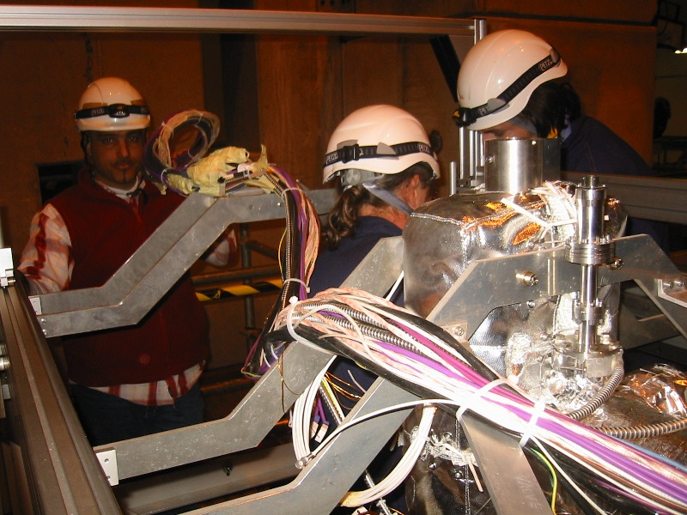 | TBD
33 | TE/VSC | Close the VVR valve and stop the pumping group. | 5min
34 | TE/VSC | Refill sectors with N2 at atmospheric pressure. | 10min
35 | TE/VSC | Remove the connection between the pumping group and the flange with the pumping port of the chamber VC2C. | 5min
36 | TE/VSC | Remove the flange with pumping port of the VC2C chamber, and protect the flange of the chamber VC2C with aluminium foil. | 5min

37 | ALICE | The Cage can be move through the TPC.  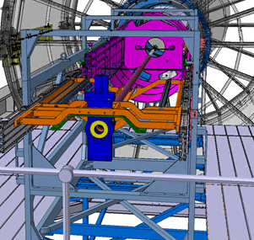
38 | ALICE | Move the Cage inside the TPC by 2.5 meters and install the extension bar on the BP temporary support.  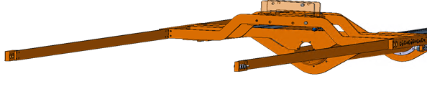
39 | ALICE | Continue the translation of the Cage along the rails through the TPC to the final position. Monitor rails sagging or deflection.
40 | ALICE | Block the Cage and BP by locking the BP temporary support to the temporary rails. Note this step is critical, the Valve has to be locked otherwise during the BP bake out the valve will be pulled in the absorber direction and will squeeze the bellow due to the action of the vacuum.  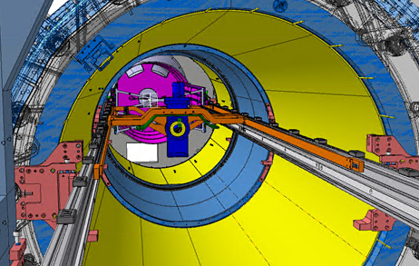
41 | ALICE | Remove only the closest top and bottom carbon covers from the C-side to provide access for BP connection.  TOP should be enough to be decided in situ…  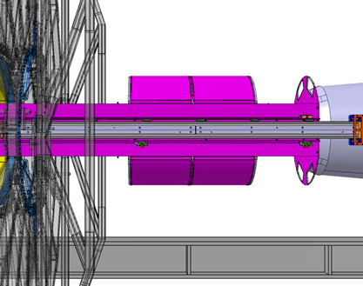
42 | TE/VSC | Insert two screws to maintain both flanges OD86 aligned.  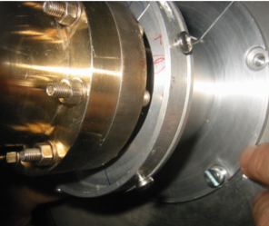 | 5min
43 | TE/VSC | Extend the bellows with the tooling installed on it. | 10min
44 | TE/VSC | Connect the BP flanges at absorber side. Install a new Helicoflex seal ref. 204606. This connection will require to stretch the bellow by 15mm.  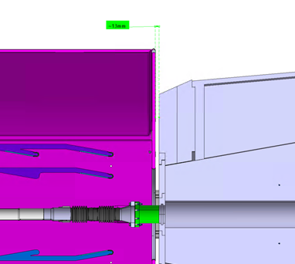 | 30min
45 | TE/VSC | Remove the bellow tooling. | 5min
46 | ALICE | Install the top brackets of BP, middle side and C-Side. For the bracket in the middle side, watch the cables from the heating element. They must pass on the top of the bracket. Keep brackets bolts loose.
47 | TE/VSC | Check that a pumping group, equipped with a magic box, is installed in A1R2.X sector and connected to the manual valve, between MBXWT magnet and Q1. | 2min
48 | TE/VSC | Verify that the pumping group is working. | 10min
49 | TE/VSC | Check the pressure in the sector A1R2.X, it should be at atmospheric pressure. If not, fill with N2 the sector through the venting valve on the magic box. | 2min
50 | TE/VSC  /ICM | Open the valve VVGSW.191.1R2.X, interlock to be bypassed – block open and the Valve VVGMT. | TBD
51 | TE/VSC | Verify sector valves position:  - VVGMT.43.1L2.X OPEN (manual valve, with blank flange)  - VVGSW.191.1R2.X OPEN  - VVGSF.221.1R2.X CLOSED | 5min
52 | TE/VSC | Check the Cage and BP is locking to the temporary rails. | 5min
53 | TE/VSC | Open all-metal manual valve and pump down experimental beam chambers to less than 1E-06 mbar on pumping group. | 12hr
54 | TE/VSC | Tightness of manual valve (all metal valve on VAX station)  - Close the manual valve on the VAX.  - Close the group isolation valve (VVR) and make a venting of the flexible between VVR and manual valve via the variable leak valve (VLV ) by removing the DN16 blank flange. Check the pressure in the experimental chamber:  - If the manual valve is not leaking, close the VLV, close the DN16 flange, pump again the magic box and continue with the pump down and leak detection.  - If the manual valve is leaking, change it and close the VLV.  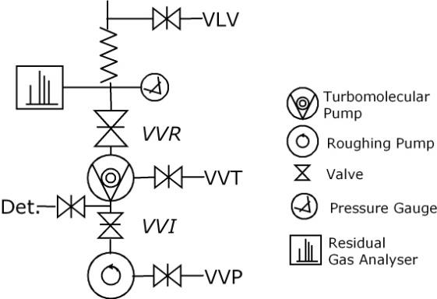 | 15min (WO leak)
55 | TE/VSC | Install a leak detector on the pumping group and start it. Connect the leak detector on the computer to save the data of the measurement.  - Measure the background of the detector during 10min, should below 1E⁻¹⁰mbar.l/sec.  - Close VVR and open the Det. Valve, measure the leak rate during 10min  - Open VVR measure the leak rate during 10min | 40min
56 | TE/VSC | Install a bag on the flanges OD86mm. | 10min
57 | TE/VSC | Seal tightness test of flange OD86  • Inject He inside the bag of the flange OD86.  - If the leakrate increase after 10min, close VVR, vent the sector with N2, change the seal, and repeat step 53, 55 and 57.  - If the leakrate is stable, pass to the next step | 15min (WO leak)
58 | TE/VSC | - Close the VVR valve on the pumping group and measure the leak rate during 10min.  - Close the leak detection valve and measure the leak rate during 10min.  The He leak test is completed. | 25min
59 | TE/VSC | Refill sectors with N2 through the VLV at atmospheric pressure. | 1hr
60 | ALICE | Remove the closest top carbon covers from the M-side to provide access for BP bakeout installation on the beryllium section.  TOP should be enough to be decided in situ…
61 | TE/VSC | Install protection around the bellows. | 10min
62 | TE/VSC | Install the bakeout equipement on the C-side section and connect the equipment of the central chamber, RB26, A1R2.X to the bakeout racks. | TBD
63 | TE/VSC | Pump down the sector following steps 48, 51 and 53 | 12hr
64 | TE/VSC | Bakeout test can be done. | TBD
 |  | The installation of the beam pipe VC2C is completed, beam pipe is ready for bake out and NEG activation following procedure EDMS n° 926404.

Assembly of the manual gate valve (VVGMT) support
Status:
- The IP2X sector is activated and under Ne.
- The bakeout equipement (non permanent) is removed.
- TPC is in its final position.
Step Nbr | Resp. | Description | Time
 | ALICE | Install main support (green parts) of the valve VVGMT:  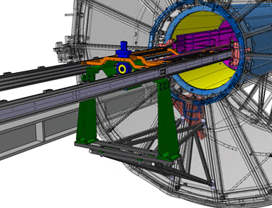
 |  | Install BP Valve support lower part | DRAFT
 |  | Install BP Valve support upper part | DRAFT
 |  | Fix BP A flange on BP adjusting table | DRAFT
 |  | Fix Valve on Valve adjusting table | DRAFT
 |  | Disconnect BP A flange form BP temporary support | DRAFT
 |  | Disconnect BP Valve form BP temporary support | DRAFT
 |  | By using micrometric adjusting tables, sitting on top of the BPVS_up transfer the load of the valve to the BP support. | DRAFT

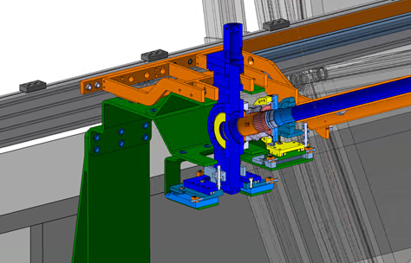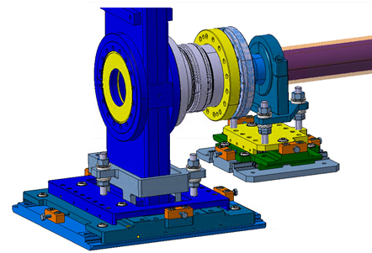

Commentaires :

Commentaires :

