PROJECT MANAGEMENT DOCUMENT

PROJECT ROADMAP

A cryogenic system for impedance measurements of accelerator components
ABSTRACT:
In order to assess the impedance of innovative surface treatments (a-C, LESS) or of High-Temperature Superconductors for use in the HL-LHC and FCC beam screens, TE-VSC proposes to build an experimental facility, aimed at the test of real components at cryogenic temperature, and in presence of a multi-Tesla magnetic field. Such a facility is does not presently exist at CERN, or in other collaborating institutes.
This document summarizes the requirements and draws a project-oriented approach for the design and fabrication of such a facility
DOCUMENT PREPARED BY: | DOCUMENT CHECKED BY: |  | DOCUMENT APPROVED BY:
Sergio Calatroni | Vincent Baglin TE-VSC  Paul Cruikshank TE-VSC  Germana Riddone TE-VSC  Johan Bremer TE-CRG  Torsten Koettig TE-CRG  Benoit Salvant BE-ABP  Daniel Schulte BE-ABP  Frank Gerigk BE-RF  Christine Vollinger BE-RF  Walter Wuensch BE-RF  Amalia Ballarino TE-MSC  Vittorio Parma TE-MSC  Diego Perini EN-MME |  | José M. Jimenez TE  Lucio Rossi HL-LHC  Michael Benedikt FCC  Paolo Chiggiato TE-VSC  Dimitri Delikaris TE-CRG  Luca Bottura TE-MSC  Gianluigi Arduini BE-ABP  Erk Jensen BE-RF
DOCUMENT SENT FOR INFORMATION TO:
Mauro Taborelli TE-VSC  Cedric Garion TE-VSC  Giuseppe Bregliozzi TE-VSC |  | Sergey Arsenyev BE-ABP  Daniel Schoerling TE-MSC  Marta Bajko TE-MSC

HISTORY OF CHANGES
REV. NO. | DATE | PAGES | DESCRIPTIONS OF THE CHANGES
1.0  1.1  1.2 | 2018-06-05  2018-09-14  2018-10-11 | 8  8  8 | First version  Final version with comments from approval circuits integrated  Budget revision and clarification of FRESCA use

TABLE OF CONTENTS
1. EXECUTIVE SUMMARY 4
2. PROJECT DESCRIPTION 4
2.1 Stage 1 5
2.2 Stage 2 6
2.3 IDENTIFICATION OF STAKEHOLDERS AND PROJECT SPONSORS 6
2.4 PROJECT PHASING, PLANNING AND ORGANIZATION 6
2.5 PROJECT COSTING AND FUNDING REQUIREMENTS 7
3. REFERENCES 8

EXECUTIVE SUMMARY
CERN is developing several innovative surface treatments (for example a-C coatings [1], LESS [2], HTS coatings [3]) in the context of the HL-LHC project and the FCC design study, with the goal of applying them to the magnets’ beam screens and other machine components. Moreover, new concepts for vacuum components are being developed, for example new RF finger [4] and vacuum interconnect designs [5]. Their impact on beam impedance needs to be carefully evaluated.
CERN lacks at present an experimental facility to characterize the impedance of vacuum components at low temperature. Room temperature measurements might indeed be performed on some components [6], but these measurements cannot be easily extrapolated to the real operating conditions, namely to cryogenic temperature in the presence of a strong magnetic field. We thus propose a project aimed at the design and manufacturing of a facility for evaluating the surface impedance of test pieces of realistic size and geometries, with a focus on beam screens. Such a facility should eventually be able to operate at variable temperatures, ideally in the whole range from 300 K down to 4.2 K (1.9 K). The surface impedance should be evaluated in the presence of a dipolar magnetic field, perpendicular to the axis of the components, up to very high fields (11-15 T), and over a wide frequency range spanning from GHz down to MHz, which typically is the most relevant for beam dynamics. The aimed sensitivity shall be compatible with the foreseen surface treatments of copper (namely, a-C coating and LESS laser treatment) and with HTS coatings (Tl-1223 and ReBCO).

PROJECT DESCRIPTION
Measurements of impedance of beam-screen like pieces had been performed during the LHC design phase [7] at low temperature and in presence of a magnetic field. The two-rod design employed for those measurements will be the reference design of our project. However, in order to extend the measurement reach to fulfil the requirements of HL-LHC and FCC, several modifications and improvements are needed and other designs could be evaluated, namely single-rod, dielectric-loaded resonators, telescopic-coupled systems and possibly others.
The RF impedance measurement system shall be integrated in an anti-cryostat adapted to the bore of a suitable high-field dipole magnet, such as the FRESCA [8] or FRESCA2 facilities, or any other suitable magnet, which will be identified during the study also taking into account its accessibility and the resources needed for its operation.
The main technical requirements for the impedance measurement system are:
  - Impedance measurements shall be performed in a frequency range MHz <-> GHz, of interest for beam impedance
  - Measurements shall be performed in presence of a multi-T magnetic field (LHC: 8.66 T, HL-LHC: 11 T, FCC: 16T)
  - Impedance measurements shall be performed as a function of temperature in the entire continuous range 300 K to 4.2 K (1.9 K)
  - Measurements shall be performed on real beam screen sections
  - Surface resistance sensitivity shall be adapted to both ranges R_{s} > R_{s} Cu (in case of plain Cu beam screens, LESS, a-C) and R_{s} < R_{s} Cu (for HTS coated beam screens)
A possible illustration of the final technical solution is illustrated in Fig. 1.
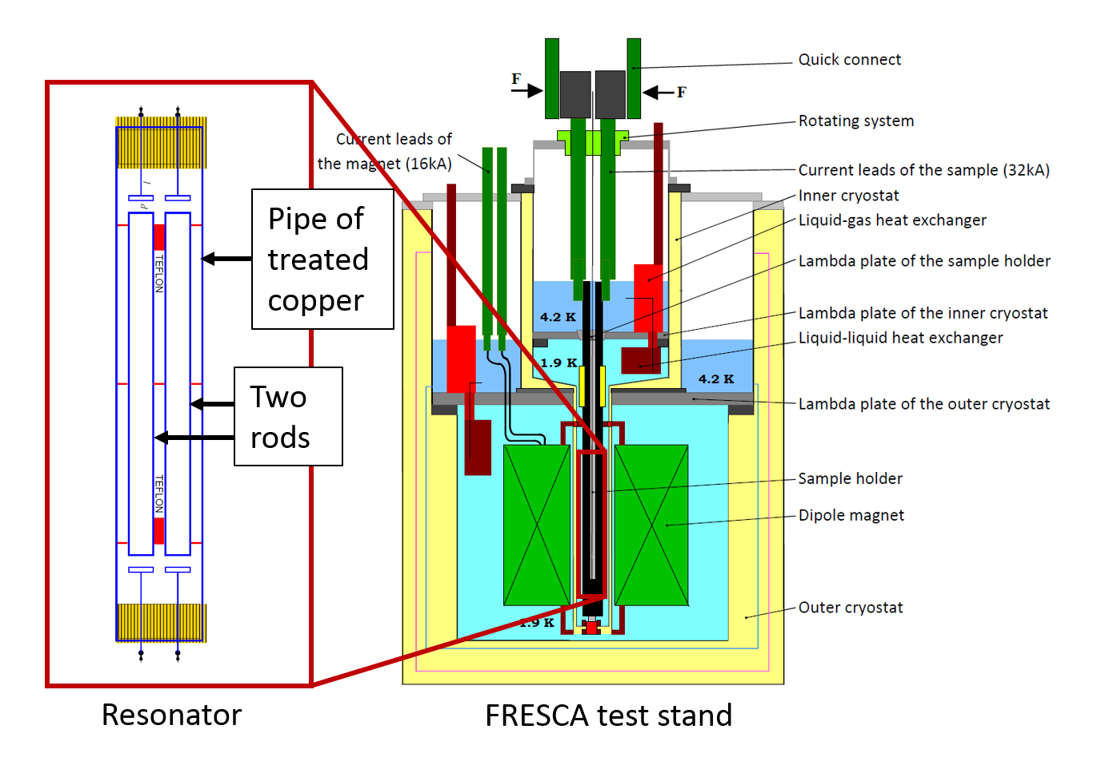
Figure 1: Possible graphical implementation of the RF test system inside FRESCA

The use of this system could then potentially be extended in future to multipacting measurement at cold (with a high power RF source), to the study of B-field perturbation due to persistent currents in HTS-coated beam screens (and the “flux shaking” phenomenon), to the study of the efficiency of bulk HTS magnetic screens and to the study of transient beam effects due to quench heaters.
We thus propose a three-year staged project to address and complete all the design and manufacturing milestones.

Stage 1
In a first phase, the RF test configuration (wire or double-wire measurement, dielectric loading, etc.) will be studied through RF simulations and implemented with simple laboratory-scale equipment, in order to validate its efficiency at room temperature and in an existing cryostat at the Cryolab.
In parallel, information will be gathered from ICMAB and UPC – Barcelona (FCC-HTS Collaboration) on optimal configurations for RF tests in a strong magnetic field

Stage 2
In a second phase, based on the above evaluation and possibly in parallel with it, an anti-cryostat will be designed and manufactured. This will be adapted to an existing high-field dipole such as e.g. FRESCA for hosting the final RF test facility. This shall ultimately allow for the characterization of realistic beam screens segments up to ~500 mm long.
More details on the technical solutions and the proposed staged approach may be found in https://indico.cern.ch/event/706627/

IDENTIFICATION OF STAKEHOLDERS AND PROJECT SPONSORS
This project and the final experimental facility will be coordinated by TE-VSC, who will seek the financial resources for manpower and materials. Key stakeholders are:
- TE-VSC: project owner & coordination, prototyping support.
- TE-CRG: tests at the Cryolab, support for cryogenic design, controls and operation of the final system
- TE-MSC: support for the design of the final cryostat insert, availability and operation of FRESCA
- EN-MME support for the design and manufacturing of the system
- BE-ABP: support for the definition of the scope, design, and use of the experimental data for beam dynamics evaluations
- BE-RF: support for the design and optimisation of the test and final systems, and for definition of data acquisition and analysis.
Resulting experimental data will benefit:
- HL-LHC project (a-C, LESS studies)
- FCC study (LESS, HTS studies)

PROJECT PHASING, PLANNING AND ORGANIZATION
As already discussed, the project will be divided into two major phases, whose key timeline is developed in the chart of Fig. 2. Major milestones will be:
- Assessment and definition of the optimal measurement configuration, and launch of design & fabrication of the final system
- Start of the commissioning of the final system
From Y3 and after commissioning, the system will be available for measurements, which should last one week each. Six weeks a year of operation in FRESCA could be envisaged. This project could start in September 2018, upon hiring of a suitable PhD student.

Figure 2: GANTT chart of the proposed project timeline

PROJECT COSTING AND FUNDING REQUIREMENTS
Direct material costs are estimated in the following Table 1:
Table 1: Direct material costs

It should be noted that the cost of the final system is an estimate, performed together with the relevant group experts, based on the cost of similar cryostats and systems. The details will be elaborated in due course of the project.
It is proposed that this project be the object of a PhD study and that from the second year (i.e. stage 2) a Senior Fellow joins the project in order to reinforce the design and commissioning of the final system.
Required new personnel resources (Table 2):
Table 2: Personnel

Other personnel resources (summarized in Table 3):
TE-VSC: 0.5 FTE/year (supervision, coordination), and 0.1 FTE/year (laboratory support)
TE-CRG: 0.2 FTE in Y1 (Cryolab support, design), 0.1 FTE/year each from Y2 for design support and commissioning.
TE-MSC: 0.2 FTE (engineer) in Y2 for engineering design and fabrication follow-up, 0.1 FTE (engineer) in Y3 for commissioning of the cryostat and 0.3 FTE (technician) for FRESCA operation
BE-ABP: 0.3 FTE in Y1 and Y2 for support in design and electromagnetic measurements and simulations, 0.2 FTE in Y3 for support in commissioning
BE-RF: 0.1 FTE in Y1 and Y2 for support in design and electromagnetic measurements and simulations, 0.2 FTE in Y3 for support in commissioning
EN-MME: 0.25 FTE (designer) in Y2 for detailed design and fabrication follow-up. (No FTE specified for fabrication. Drawing office charges and fabrication cost are included in the material budget)
Group | FTE Y1 | FTE Y2 | FTE Y3
TE-VSC | 0.5 Cat 2  0.1 Cat 3 | 0.5 Cat 2  0.1 Cat 3 | 0.5 Cat 2  0.1 Cat 3
TE-CRG | 0.2 Cat 2 | 0.1 Cat 2 | 0.1 Cat 2
TE-MSC |  | 0.2 Cat 2 | 0.1 Cat 2  0.3 Cat 3
BE-ABP | 0.3 Cat 2 | 0.3 Cat 2 | 0.2 Cat 2
BE-RF | 0.1 Cat 2 | 0.1 Cat 2 | 0.2 Cat 2
EN-MME |  | 0.25 Cat 3
Table 3: Other (existing) personnel resources

REFERENCES
  - P. Costa Pinto et al. “Carbon coatings with low secondary electron yield”, Vacuum 98 (2013) 29-36
  - R. Valizadeh et al. “Low secondary electron yield engineered surface for electron cloud mitigation”, Applied Physics Letters 105, 231605 (2014)
  - S. Calatroni “HTS Coatings for Impedance Reduction in Particle Accelerators: Case Study for the FCC at CERN”, IEEE TRANSACTIONS ON APPLIED SUPERCONDUCTIVITY, VOL. 26, NO. 3, APRIL 2016, 3500204
  - C. Garion et al. “Development of a New RF Finger concept for vacuum beam line interconnections”, 3rd International Particle Accelerator Conference, New Orleans, LA, USA, 20 - 25 May 2012, pp. 2531
  - F. Niccoli et al. “Shape-memory alloy rings as tight couplers between ultrahigh-vacuum pipes: Design and experimental assessment”, J. Vac. Sci. Technol. A 35 (2017) 031601
  - https://impedance.web.cern.ch/impedance/
  - F. Caspers et al. “Surface Resistance Measurements for the LHC Beam Screen”, LHC Project Report 115
  - https://edms.cern.ch/document/1236312/1

